**DATA ANALYSIS USING SQL**

1. find top 10 highest revenue generating products

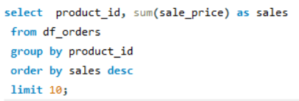

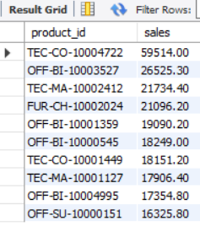

1. Retrieve all orders with a discount greater than 20%.

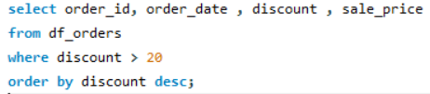

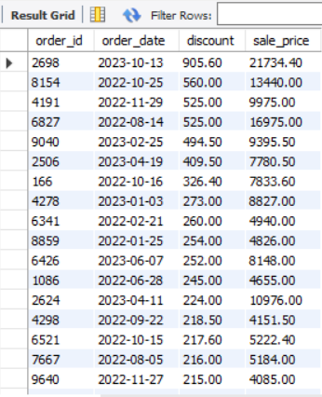

1. Find the total sales, profit, and average discount for each category.

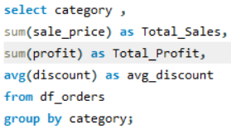

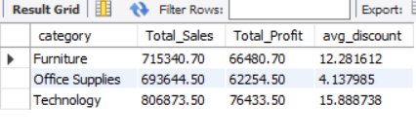

1. List the top 5 cities with the highest total sales.

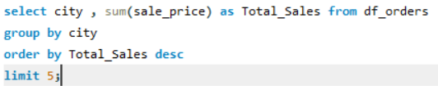

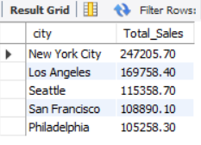

1. Find the order with the highest profit.

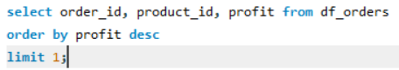

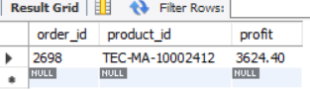

1. Count the number of orders per region.



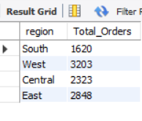

1. Identify the products that were sold at a discount greater than 30% and had a profit margin (profit/sale_price) of less than 5%.

